**EX NO.: 01 DDL COMMANDS**

**AIM:**

To work with DDL commands

**DDL (Data Definition Language):**

DDL or Data Definition Language actually consists of the SQL commands that can be used to define the database schema. DDL is a set of SQL commands used to create, modify, and delete database structures but not data.

**PROCEDURE:**

**Step 1**: Open Run SQL on Command line and connect to SQL

**Step 2:** Then work with database using SQL queries.

**CREATE:**

This command is used to create the database or its objects (like table, index, function, views, store procedure, and triggers).

**SYNTAX:**

CREATE TABLE table_name

(

column_Name1 data_type ( size of the column ) ,

column_Name2 data_type ( size of the column) ,

...

column_NameN data_type ( size of the column )

) ;

**OUTPUT:**

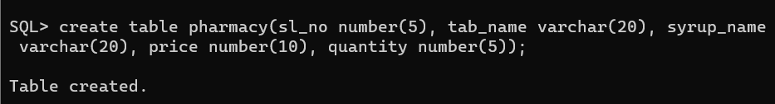

**ALTER:**

This is used to alter the structure of the database.

**ALTER ADD:**

**Syntax to add a new field in the table:**

ALTER TABLE name_of_table ADD column_name column_definition;

**OUTPUT:**

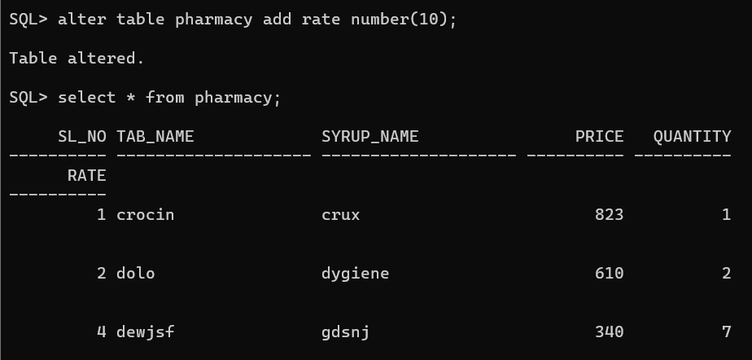

**ALTER DROP:**

**Syntax to remove a column from the table:**

ALTER TABLE name_of_table DROP

Column_Name_1 , column_Name_2 , ….., column_Name_N;

**OUTPUT:**

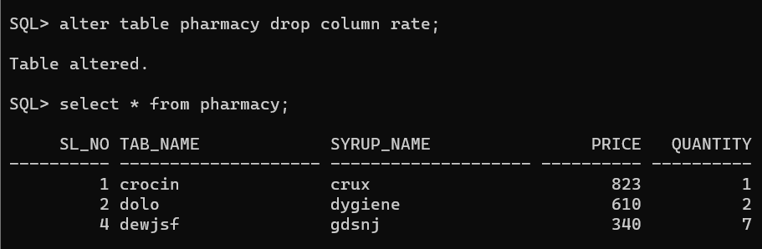

**ALTER RENAME:**

**Syntax to Rename a column from the table:**

ALTER TABLE name_of_table RENAME

Old Column_Name to New Column Name;

**OUTPUT:**

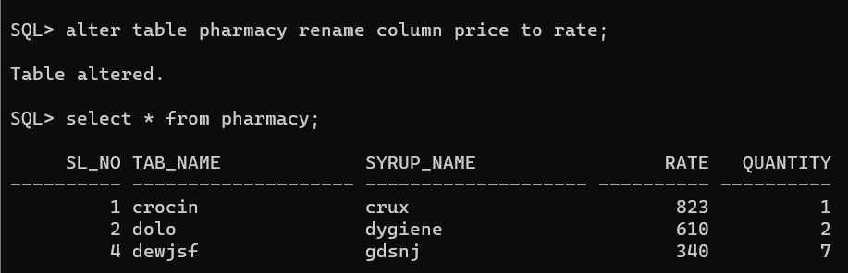

**ALTER MODIFY:**

**Syntax to modify the column of the table:**

ALTER TABLE table_name MODIFY ( column_name column_datatype(size));

**OUTPUT:**

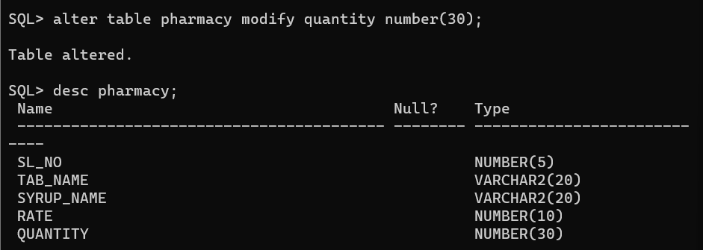

**RENAME:**

This is used to rename an object existing in the database.

**Syntax of rename command:**

RENAME TABLE Old_Table_Name TO New_Table_Name;

**OUTPUT:**

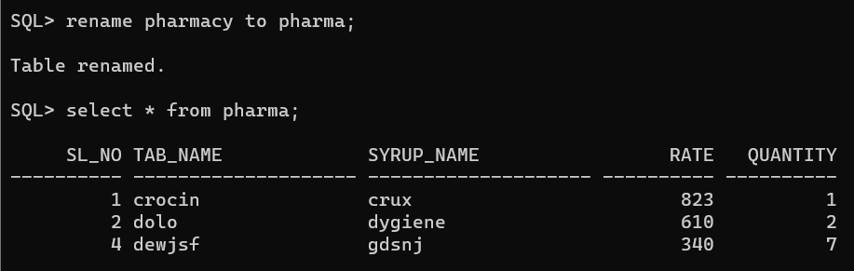

**TRUNCATE:**

This is used to remove all records from a table, including all spaces allocated for the records are removed.

**Syntax of TRUNCATE command:**

TRUNCATE TABLE Table_Name;

**OUTPUT:**

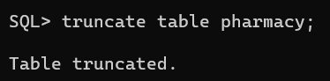

**DROP:**

This command is used to delete objects from the database.

**Syntax to remove a table:**

DROP TABLE Table_Name;

**OUTPUT:**

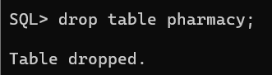

**RESULT:**

The queries for DDL commands were successfully executed and the output is noted.